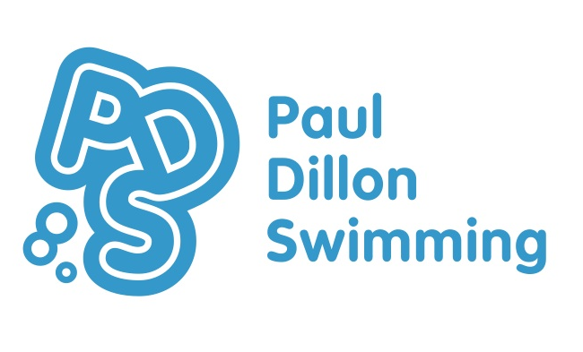
info@pauldillonswimming.com
www.pauldillonswimming.com
20 Dersingham Road
NW2 1SL
0208 8309939

An Independent Swimming School For Children Aged 3 1/2 – 14 Years

Paul Dillon Swimming (PDSC LTD.)
Terms and Conditions

Payment Terms

Fees must be paid in full on the date stated on the invoice. If payment is not received by this date then your place cannot be guarantee
To pay online our bank details are: PDSC LTD. Sort Code: 20.94.48 Account no.: 90545341. When paying online please include your child's full name or invoice number as the payment reference.
If you prefer to pay by debit card, please contact the office on 02088309939. We do not currently accept American Express.
Please note that we NO LONGER ACCEPT CHEQUES as they delay the payment process and cause large amounts of extra work in reconciliation as well as additional banking charges.

Missed Lessons

Fees are calculated on a termly basis (allowing for any bank holidays). Please note that our terms roughly follow the UCS School terms but term dates are confirmed in advance at the time of booking. Unfortunately, we cannot offer a reduction in fees for children who miss lessons during the term for any reason. Lots of children miss lessons and while we try extremely hard to make up any lessons over the course of the term by filling in any slots where someone else is away. This is not always possible and if not, while unfortunate, there is very little that can be done. During any missed lesson, while that child is away, all running costs stay the same. We cannot guarantee any make up lessons for non-attendance.

Cancellation policy

If for whatever reason, a child is no longer able to attend the remainder of term we will try to find another child to take their place and a refund will only be possible on this basis.

Changing Room Access at UCS Active

As many of you are aware there are now some restrictions as to our use of the male changing rooms during our after school swim programme. The male changing rooms are now in use by UCS School for those boys attending afterschool sport programmes. Therefore no male parents or carers may accompany children using the male changing rooms. Male parents and carers accompanying young children who may need support/supervision when changing are kindly asked to use the disabled changing rooms next to the pool. Weekend lessons remain unaffected. We thank you for your understanding on this.

From September 2016 the swim school will no longer have access to either of the main changing rooms (both Male and Female) until 3.50pm. The only changing room available will be the disabled changing room. This means that there will be very limited changing space available at the pool for those children attending lessons at 3.30pm, although they will be able to access the main changing rooms to change after their lesson. Children swimming at 4.00pm will be able to access the changing rooms from 3.50pm onwards. This is also due to changes in the UCS School timetable.

We would also like to remind parents that children older than 8 years old may not use the changing room designated for the opposite gender.

Food

PLEASE DO NOT FEED YOUR CHILD BEFORE THEIR LESSON. We’ve had several recent incidents of children being sick in the pool which meant we had to close the entire pool for cleaning, ruining the other children’s lessons. Therefore, please refrain from feeding your children less than 45 minutes before a lesson. We reserve the right to refuse entry into the pool if children are seen eating directly before their lesson.

Phones and Cameras

NO PHONES or CAMERAS may be used AROUND THE POOLSIDE OR VIEWING GALLERY. This is basic child protection policy.

Loss of your place at Paul Dillon Swimming

Lessons are bookable per term (with the exception of intensive holiday courses). During the week following half-term we will offer you the option of rebooking your current slot for the next term. Please note that if we do not hear from you by the rebooking deadline date then we will offer your space to someone on our waiting list. If you contact us after the rebooking deadline has passed we will do our very best to offer you an alternative day or time. If this is not possible you will be placed on our waiting list. Although we try to ensure that we make an effort to contact all parents before giving away their child’s place for the following term, this isn’t always possible. It is your responsibility to ensure that we have the correct and up to date contact details for your family so please do let us know if these change during the term.
Paul Dillon swimming reserves the right to terminate your child’s lessons in the event that any fees remain unpaid, where any of the terms and conditions are breached, or termination of a place is considered to be in the best interests of the swim school.

Personal Effects

Paul Dillon Swimming and the UCS Active Centre accept no responsibility for any personal belongings that are brought to the centre. In the event that you do mislay any personal effects, please contact UCS Active in first instance to confirm if it has been received by lost property.

Obligations of Parent / Guardian

You undertake to notify Paul Dillon Swimming of (for example but not limited to) any medical or educational situations where special arrangements may be needed to your Child. For the avoidance of doubt this obligation extends to informing Paul Dillon swiiming about any health/medical condition, disability / allergy that your Child has or develops whether long or short term including any infection(s). For the benefit of all other children attending the swim school, you must not allow your child to attend their swim lesson if they are suffering from any contagious disease / illness.
You undertake to inform us of any change in your contact information, this is essential to enable us to contact you in the event of lesson cancellations, etc.

I confirm I have read and understood the terms and conditions for my child’s lessons at Paul Dillon Swimming

Signature………………………………………………… Date…………………….

